Guide Association Cumbria North
Accounts 2023

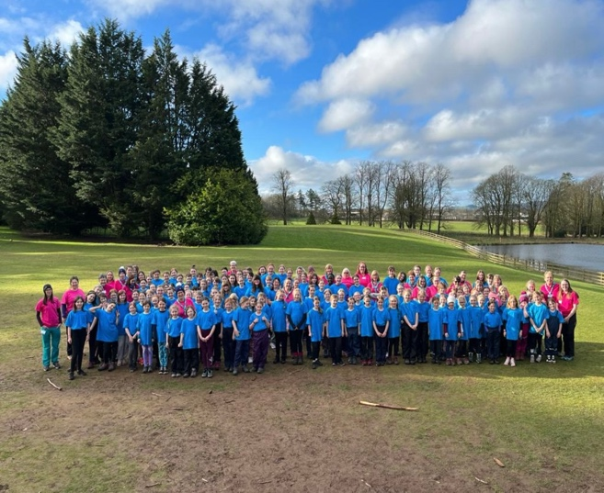
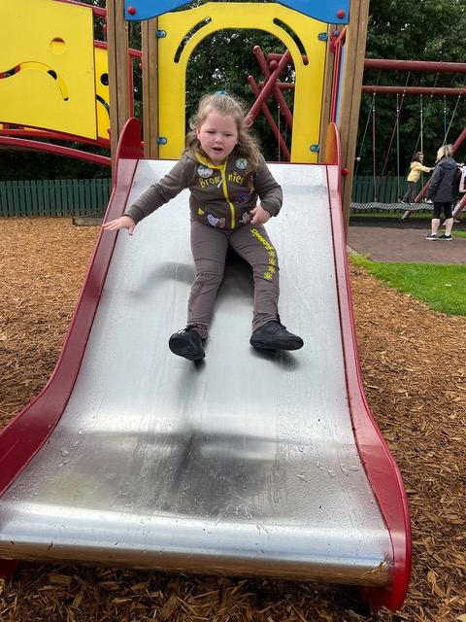



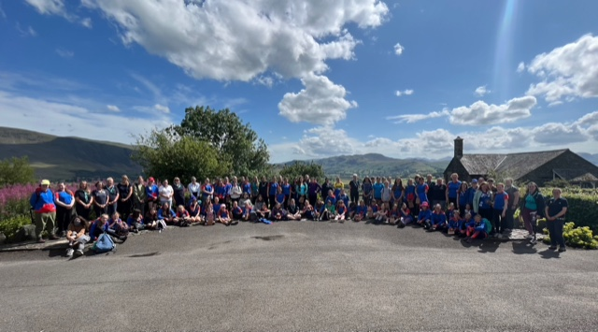

Guide Association Cumbria North
Year ended 31 December 2023

INDEX
Charity Details
Charity Trustees Report
Independent Examiners Report
Income and Expenditure account
Statement of assets and liabilities
Appendix A Risk Assessment

Charity Details
Name | Charity Trustee | County Executive Member | Division Commissioner | Other Role
Ann-Marie Steel | X | X |  | County Commissioner
Helen Marrs | X | X |  | Assistant County Commissioner
Lorraine Bearchell-Healy | X | X |  | Assistant county commissioner
Pauline Wright | X | X | X
Gillie Young | X | X | Part of team
Audrey Grey | X | X | X
Nicky Vatter | X | X | Part of team
Alex Crawford | X | X | Part of team
Dawn Cannon | X | X | X
Jenny Cruden | X | X | X
Charlotte Wood | X | X | X
Christine Eglin | X | X | X
Anne Livingstone | X | X | X
Catherine Adam | X | X | X

Guide Association Cumbria North
Year Ended 31 December 2023
Charity Number 503517
Bankers
Cumberland Building Society, Fisher Street, Carlisle
CAF Bank Ltd, 25 Kings Hill Avenue, Kings Hill, West Malling, Kent, ME19 4JQ
Examiner of Accounts:
Claire Raven
Eaglesfield Paddle Academy
5 Main Street
Greysouthen
Cockermouth
CA13 0UG
07855936314

Contacts:
Mrs Ann-Marie Steel
Email: countycommissionercumbrianorth@gmail.com
Telephone: 01900 821719

Trustees’ Report
Charity Trustees’ Annual Report for the Year Ended December 2023

Structure, Governance and Management
Governing Document
The Charity’s formal name is The Guide Association Cumbria North. Its operations name is Girlguiding Cumbria North and is often referred to in this report as the County. The charity’s governing document is the Guide Association Royal Charter of 1922. The Royal Charter and byelaws, the Guiding Manual, various Handbooks and the County Constitution together determine how the charity is governed.

Organisational structure
The Guide Association
(known as Girlguiding)
Charity No. 30616
The Guide Association North West England
(the Region)
Charity No: 521694
The Guide Association Cumbria North
(the County)
Charity No: 503517

The Guide Association Cumbria North is constituted as a branch of the Guide Association in accordance with the Royal Charter, and has the status of a Girlguiding County within the North West England Region of the Guide Association. The structural organisation of the Guide Association is linked through:
- The appointment of Commissioners and Guiders. The County Commissioner is appointed by the Region Chief Commissioner and is an ex officio voting member of the Region Executive Committee. The County Commissioner appoints the Division Commissioner, and the Division Commissioner appoints a team to assist, or District Commissioners, as appropriate.
- Shared commitment to the objects of the Royal Charter and adherence to the rules and regulations set out in the Guiding Manual and Association handbooks.

Within Girlguiding and as accepted by the Charity Commissioners, the various organisational levels retain separate identities for charity registration and accounting purposes. Accordingly, no consolidated accounts are prepared, and the County’s accounts do not include the transactions or assets and liabilities of any Division, District or Unit within the County. The financial administration of the County is subject to the Rules and other provisions of the Guiding Manual and charity law.
Recruitment, appointment, induction and training of new trustees.
The Guide Association’s Chief Guide appoints the Region Commissioner, who in turn appoints the County Commissioner(s), who in turn appoints the 8 Division Commissioners within the County, and Assistant County Commissioner and the Chair of Finance. The holders of these posts are voting members of the County Executive and the Charity Trustees of the Guide Association Cumbria North. They serve as charity trustees for the term of their respective appointments, which in the case of the County Appointment Holders other than the County Commissioner, terminate on the expiration of the County Commissioner’s term of office.
Charity Trustees serve for a term of office of up to 5 years but would be removed as a Charity Trustee should they cease to hold office as a Division Commissioner for any reason before their anticipated term has expired. The Assistant County Commissioner (if any) is appointed with each new County Commissioner.
Charity Trustees are assigned a mentor who ensures that informal training is available to meet individual needs. They also follow the Guide Association induction programme for Division Commissioners, which prepares them for the management of their Divisions.

Risk Management
The Charity Trustees have reviewed the major strategic, business and operational risks, which the charity faces. These will be detailed in a risk register and the trustees’ annual review programme is in place. Policies, systems and processes exist to mitigate risks as far as possible. See Appendix A.

Objectives and activities
Objective
To pursue the objectives of the Guide Association concerned with the development of girls and young women.

Aim
To educate girls and young women to help them develop emotionally, mentally, physically and spiritually so that they can make a positive contribution to their community and the wider world.

Strategies for achieving objectives
Our strategy for achieving the objective has been twofold:
- Provision of activities for girls and young women
- Direct training of adult leaders
The Charity Trustees have referred to the information contained in the Charity Commission’s general guidance on public benefit when reviewing the aims and objectives and in planning future activities. The Charity Trustees believe that the activities carried out benefit the public by aiding the personal development and wellbeing of girls, young women, and adults through the pursuit of the Association’s Aims and Activities.

Review of Activities during the past year
2023 was dedicated to getting units and leaders back out again, meeting each other, rebuilding confidence, and having fun!
With this in mind we invested heavily in funding a weekend in Lockerbie for Brownies and Guides. We also held several Section specific activity days through the summer months.
Lockerbie was a blast. We had 130 girls and 25 leaders attending. Brownies occupied the Manor house and Guides and their leaders slept in the Pod house villages. Activities ranged from Archery, High and Low ropes, Abseiling, Paddleboarding, Obstacle courses and Crate stacking, to name but a few. It was great to see leaders and girls from across the County arrive on 3 different buses and make new friendships, gain confidence in being away and having a huge amount of fun.
Our Rainbow section had a blisteringly hot inflatable day in Keswick. They bounced for hours and enjoyed ice-lollies to help cool them down.
Brownies had a damp trip to Dalscone Farm in Dumfries, but the weather didn’t stop the fun. We had a few sleeping girls on arrival back home!
At Blencathra field centre, the Guides had an environment day, exploring the flora and fauna, building dens and pond dipping.
All the girls enjoyed the badges that were created for all the events, which of course whet their appetites to do more as units and divisions.
Opportunities for our young members and leaders are created at all levels within the Guide Association. Cumbria North County (the County) continues to invest heavily in ways of providing section training for its adult members during the year along with other trainings specific to activities, Safeguarding, and First Response.
This continued again for our County through the last year. We continued to offer face to face First Response trainings, with both our own Girl guiding trainee Ann-Marie and Daisy First Aid providing the training for leaders.
Levels 1 and 2 A Safe Space were easily accessible through e-learning modules and level 3 and 4 were delivered nationally and via Region trainers online, making it more accessible and less time consuming without having to travel. With the introduction of the e-learning level 3 training, this makes it even more convenient for leaders to renew their qualification. Thank you to everyone who kept their training requirements up to date for First Response and safeguarding compliance.
The number of section awards that were completed by the girls over the year grew again from the previous year, with orders being received almost on a weekly basis. It has been lovely to hear what the girls achieved for their Gold award, and we’ve seen beautiful unit flags, to introducing themed evening into units meetings and many fundraising achievements. A huge well done to the girls for completing all the required interest badges, skills builders, and Unit Meeting Activity minutes and to the leaders for encouraging them to complete the necessary requirements.
A County international trip had been decided and we saw the girls and leaders attend many events to help with fund-raising over the year. I hope their trip to Canada in 2024 is amazing.
County training day was arranged and advertised for 2024 and bookings were starting to come through. It looks like it will be a great weekend in April 2024.
County Guide camp dates were set for 2024 at Ratlingate.
Across the divisions we saw numbers go up and down. New units were opening for some, whilst some sadly closed. New banners and Sails were purchased with the new Girlguiding branding, to use at events to promote the opportunites for girls and adults and fliers were distributed to units to promote themselves in their local area. Hopefully we will see a rise overall next year in numbers.
We are always grateful to our many Adult Leaders and unit helpers who are so committed to ensuring that the Rainbows, Brownies, Guides, Rangers, and young leaders all have the opportunity to become well rounded citizens of the future. It’s been a year full of excitement and confidence building and we know that 2024 will see many more units out and about enjoying their own pack holidays, day trips and camps.
At the end of the year cash balances amounted to £110,674.28
The County do not own or have a lease over any premises.

General Comment
The accounts have been prepared on a cash basis.
The Charity Trustees’ policy on reserves is to hold funds against specific purposes. Interest arising from reserves is to be used to support the work of Guiding in Cumbria North or is to be reinvested to maintain the value of the reserves. The main source of income is from Subscriptions which is received once a year from all members within the County and a grant from Cumbria County Council.
The grant from the Cumbria County Council is awarded on a one-year contract, and there are no guarantees that this will continue indefinitely, with the merger of the 2 councils in 2023. Should this support be withdrawn, our reserves will help to ensure that County will still be able to support its members.
All funds are held in the General Fund. There are no restricted or designated funds. General funds are held to enable the administration of the County to continue and amount to 2 years running costs including all member’s subscriptions. If a unit is unable to pay its subscriptions at national level, then County is responsible for this. In 2023, all units met the final date deadline for paying their Annual Subscription.
Investments are held with different financial bodies: Cumberland Building Society, and CAF Bank Ltd. All members can claim grants for expenses incurred in training and international opportunities so that we can allow our members to experience all that Girlguiding has to offer, across the world, and to meet our aims of widening our membership but also to give all our members to opportunities to explore and grow into excellent role models for all the young people around them, We are proud of all of our member and continue to do all we can to support them on their life journey. Cumbria North County Executive are very grateful to its leaders for all they have done for the girls over the year.

Restricted Funds and Designated Funds
None of the funds held are classed as restricted of designated.
Cash funds of £110,674.28 are held in the County bank and building society accounts as shown in the detailed statement of assets and liabilities on page 15.
The general funds are used towards the development of Guiding throughout the County. Units or individual members can apply for assistance for grants to support them in running their units, this includes contributions towards training, or taking girls away both in this country and internationally.
Running Costs Capital £94,623.74 (this is made up of the county expenditure together with the subscription levy for each member. There is a Reserve fund for running costs in case there is no income in any particular year, this is the amount held in the Cumberland Building Society. We can continue to maintain this as we presently receive a grant of approximately £10,000 per year, from Cumbria County Council towards the provision of Youth Services. A grant of £20,000 is paid into the accounts of Cumbria North, but we share this grant with Cumbria South, and it is portioned up in proportion with our numbers. The distribution with Cumbria South continues and payments were given to divisions based on the number of girls at the time of subscriptions.

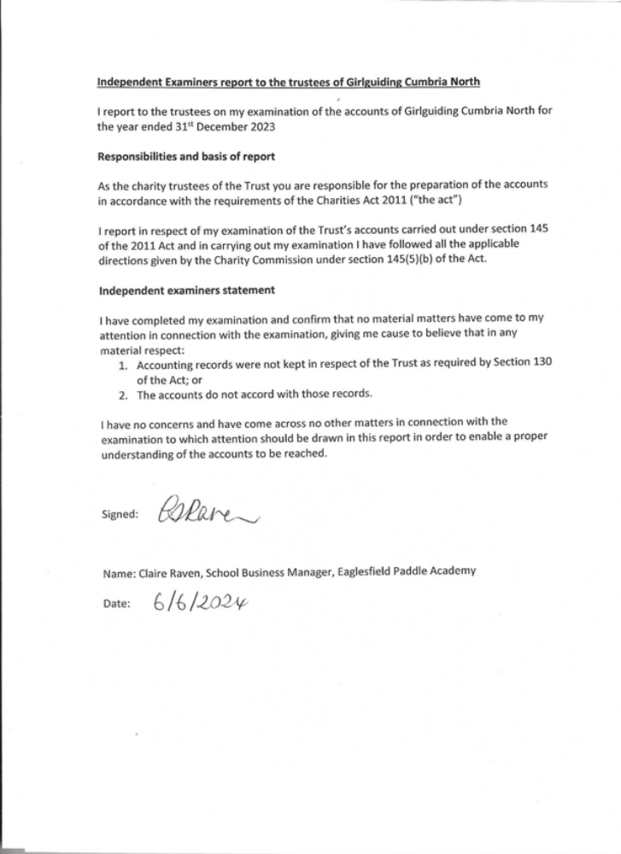

THE GUIDE ASSOCIATION – CUMBRIA NORTH COUNTY – REGISTERED CHARITY – 503517

INCOME AND EXPENDITURE ACCOUNT
FOR THE YEAR ENDED 31 DECEMBER 2023

RECEIPTS | 2023 |  | 2022
total grants and Donations  Transfer from Investment account | 22,200.95  - |  | 25,222.20  -
subscriptions from members | 2388.00 |  | 3484.00
interest received | 74.21 |  | 23.13
legacies | - |  | -
camps/outings/events | 33,140.20 |  | 4480.00
training | - |  | -
Merchandise | 268.40 |  | 216.20
repayments of grants | - |  | 210.00
County Depot | - |  | 429.94
TOTAL INCOME | 58,786.24 |  | 34065.47

PAYMENTS | 2023 | 2022
Badges and Goods purchase for resale | 2,915.16 | 1564.38
Training | 1478.88 | 420.00
Travel | 1484.43 | 558.50
Rent | 2864.77 | 384.00
Donations and grants to units | 18,612.08 | 11090.19
Girlguiding Cumbria South | 9383.40 | 8232.00
 |  | 396.00
Subscriptions for County Personnel | 152.00
Bank charges | 94.80 | 96.60
County Materials | 1411.38 | 5329.98
camps/outings/event | 49,048.65 | 6112.09
International | 901.26 | 440.00
TOTAL EXPENDITURE | 80,599.66 | 34,623.74
Surplus or (deficit) for year | (21,813.42) | (558.27)

THE GUIDE ASSOCIATION – CUMBRIA NORTH COUNTY
REGISTERED CHARITY – 503517
STATEMENT OF ASSETS AND LIABILITIES AS AT 31 DECEMBER 2022

MONETARY ASSETS
UNRESTRICTED | 2023
Bank Current Account | 28,406.34
Building Society | 80,000
CAF Gold Account | 2,254.73
TOTAL MONETARY ASSETS | 110,674.28

OTHER ASSETS – ALL UNRESTRICTED
Held for use by the Charity
Resuscitation models | Replacement value £1000
Display boards and pop up banners | Replacement value £500
4 X County Centenary banners | £1,000
Camping Equipment | Replacement Value £9,500
2 x County Standards | Replacement Value £8,000
Digital Projector | Replacement Value £1,000
2 x County Banners | Replacement Value £500
2 x Gazebos | Replacement Value £2,500

Approved by Trustees on and signed on their behalf.

Ann-Marie Steel
COUNTY COMMISSIONER

APPENDIX
Girlguiding Cumbria North Risk Register

It is appreciated by the Trustees that the Finances of the County need to be protected and preserved for the benefit of the current and future members of Girlguiding Cumbria North.

To this end the Trustees have considered and made policies regarding the finances of the County.

The rating is scored from 1 being very low risk to 5 being very high risk.
Risk Register
RISK | RATE | CONTROL
Cheque Signatories | 2 | Two signatories are required for all cheques, the signatories are any two of three named.
Authorisation of BACS payments | 2 | Dual authorisation is required for all on-line bank transactions, the authorisation is from any two of three named.
Delegation | 2 | The Finance Committee reports back to the County Executive and has limited authority to act without the consent of the County Executive.
Investments | 4 | The investments of the County have been spread between a Bank and a Building Society long term investment. The risk of an investment holder ceasing to trade is considered alongside the rate of interest available for larger deposits. The security of the investments is kept under constant review and authority has been given to the cheque signatories to move funds quickly if the Finance Committee of Trustees believe it to be necessary.
Equipment | 2 | The County do not own large amounts of equipment, the County does not hold insurance for insurable objects. The level of insurance cover has been carefully considered against the cost of insurance and the replacement value of some items. The insurance is reviewed annually and when new purchases are made.

