Guide Association Cumbria North

Accounts 2022

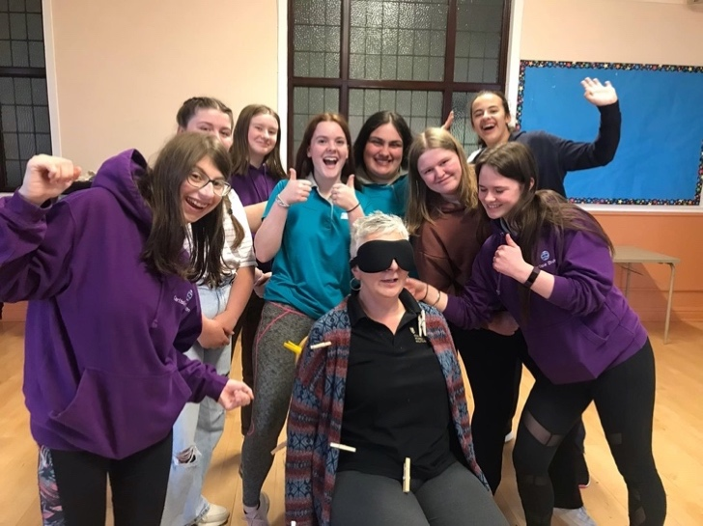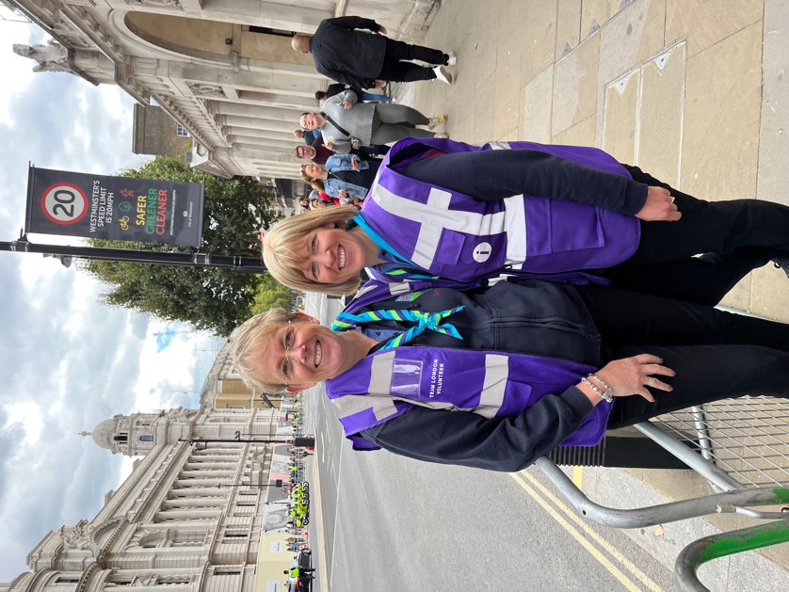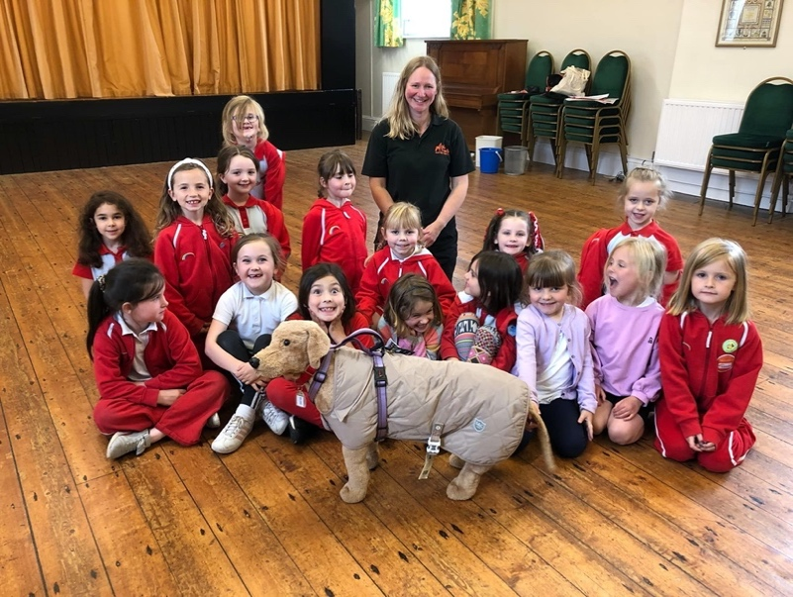

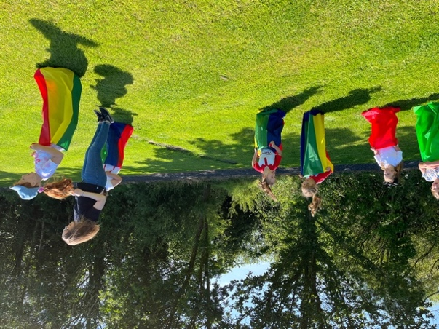

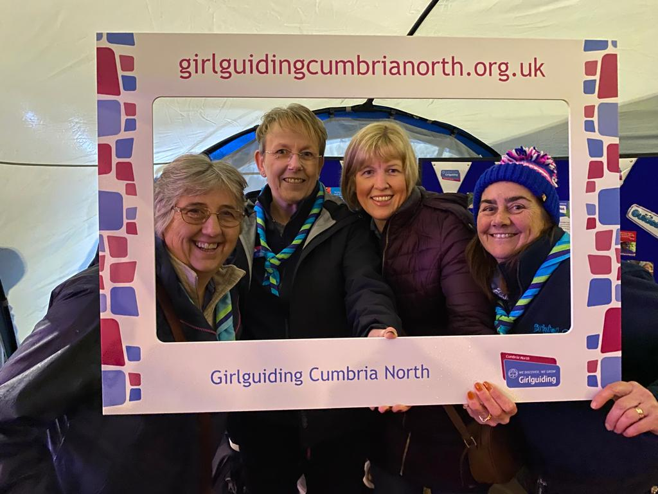

Guide Association Cumbria North

Year ended 31 December 2022

INDEX

Charity Details

Charity Trustees Report

Independent Examiners Report

Income and Expenditure account

Statement of assets and liabilities

Appendix A Risk Assessment

Charity Details

|  |  |  |  |  |
| --- | --- | --- | --- | --- |
| Name | Charity Trustee | County Executive Member | Division Commissioner | Other Role |
| Ann-Marie Steel | X | X |  | County Commissioner |
| Helen Marrs | X | X |  | Assistant County Commissioner |
| Lorraine Bearchell-Healy | X | X |  | Assistant county commissioner |
| Nicola Proudfoot | X | X | X |  |
| Sarah Hodgson | X | X | X |  |
| Georgina Stevenson | X | X | X |  |
| Nicky Vatter | X | X | X |  |
| Christine Eglin | X | X | X |  |
| Anne Livingstone | X | X | X |  |
| Alison Jary |  | X |  | County Chair of Trefoil Guild |
| Catherine Adam | X | X | X |  |

Guide Association Cumbria North

Year Ended 31 December 2022

Charity Number 503517

Bankers

Cumberland Building Society, Fisher Street, Carlisle

CAF Bank Ltd, 25 Kings Hill Avenue, Kings Hill, West Malling, Kent, ME19 4JQ

Examiner of Accounts:

Claire Raven

Eaglesfield Paddle Academy

5 Main Street

Greysouthen

Cockermouth

CA13 0UG

07855936314

Contacts:

Mrs Ann-Marie Steel

Email: countycommissionercumbrianorth@gmail.com

Telephone: 01900 821719

Trustees’ Report

Charity Trustees’ Annual Report for the Year Ended December 2022

Structure, Governance and Management

Governing Document

The Charity’s formal name is The Guide Association Cumbria North. Its operations name is Girlguiding Cumbria North and is often referred to in this report as the County. The charity’s governing document is the Guide Association Royal Charter of 1922. The Royal Charter and byelaws, the Guiding Manual, various Handbooks and the County Constitution together determine how the charity is governed.

Organisational structure

|  |
| --- |
| The Guide Association  (known as Girlguiding)  Charity No. 30616 |
| The Guide Association North West England  (the Region)  Charity No: 521694 |
| The Guide Association Cumbria North  (the County)  Charity No: 503517 |

The Guide Association Cumbria North is constituted as a branch of the Guide Association in accordance with the Royal Charter, and has the status of a Girlguiding County within the North West England Region of the Guide Association. The structural organisation of the Guide Association is linked through:

1. The appointment of Commissioners and Guiders. The County Commissioner is appointed by the Region Chief Commissioner and is an ex officio voting member of the Region Executive Committee. The County Commissioner appoints the Division Commissioner, and the Division Commissioner appoints a team to assist, or District Commissioners, as appropriate.
2. Shared commitment to the objects of the Royal Charter and adherence to the rules and regulations set out in the Guiding Manual and Association handbooks.

Within Girlguiding and as accepted by the Charity Commissioners, the various organisational levels retain separate identities for charity registration and accounting purposes. Accordingly, no consolidated accounts are prepared, and the County’s accounts do not include the transactions or assets and liabilities of any Division, District or Unit within the County. The financial administration of the County is subject to the Rules and other provisions of the Guiding Manual and charity law.

**Recruitment, appointment, induction and training of new trustees.**

The Guide Association’s Chief Guide appoints the Region Commissioner, who in turn appoints the County Commissioner(s), who in turn appoints the 8 Division Commissioners within the County, and Assistant County Commissioner and the Chair of Finance. The holders of these posts are voting members of the County Executive and the Charity Trustees of the Guide Association Cumbria North. They serve as charity trustees for the term of their respective appointments, which in the case of the County Appointment Holders other than the County Commissioner, terminate on the expiration of the County Commissioner’s term of office.

Charity Trustees serve for a term of office of up to 5 years but would be removed as a Charity Trustee should they cease to hold office as a Division Commissioner for any reason before their anticipated term has expired. The Assistant County Commissioner (if any) is appointed with each new County Commissioner.

Charity Trustees are assigned a mentor who ensures that informal training is available to meet individual needs. They also follow the Guide Association induction programme for Division Commissioners, which prepares them for the management of their Divisions.

**Risk Management**

The Charity Trustees have reviewed the major strategic, business and operational risks, which the charity faces. These will be detailed in a risk register and the trustees’ annual review programme is in place. Policies, systems and processes exist to mitigate risks as far as possible. See Appendix A.

**Objectives and activities**

**Objective**

To pursue the objectives of the Guide Association concerned with the development of girls and young women.

**Aim**

To educate girls and young women to help them develop emotionally, mentally, physically and spiritually so that they can make a positive contribution to their community and the wider world.

**Strategies for achieving objectives**

Our strategy for achieving the objective has been twofold:

1. Provision of activities for girls and young women
2. Direct training of adult leaders

The Charity Trustees have referred to the information contained in the Charity Commission’s general guidance on public benefit when reviewing the aims and objectives and in planning future activities. The Charity Trustees believe that the activities carried out benefit the public by aiding the personal development and wellbeing of girls, young women, and adults through the pursuit of the Association’s Aims and Activities.

**Review of Activities during the past year**

We very sadly lost our Patron, HRH Queen Elizabeth II, in September 2022. As a charity, there were many acts of condolences across the country and many of our County units sent pictures and cards to the Royal family expressing their sadness. Girlguiding put out a national plea to leaders to help with marshalling the crowds in London whilst her body lay in state. Ann-Marie and Helen felt very honoured to be part of the team volunteering with many other leaders from across the Country and had the opportunity to join the end of the queue at 11.30 one Friday evening to pay not only their respects but also those from Cumbria North, in uniform and were captured on TV.

2022 saw the return to almost” normal” guiding meetings again, with few restrictions still in place following the pandemic.

Opportunities for our young members and leaders are created at all levels within the Guide Association. Cumbria North County (the County) continues to invest heavily in ways of providing section training for its adult members during the year along with other trainings specific to activities, Safeguarding, and First Response.

This continued again for our County through the last year. We continued to offer face to face First Response trainings, with both our own Girl guiding trainer, Liz Watson and Daisy First Aid providing the training for leaders. The training moved to being full days for renewals, seeing the move from a refresher course. There was the introduction of the e-learning module for First response which helped give those leaders with a first aid certificate through work be able to use their training but have the Girlguiding element of policies being adhered to also.

Levels 1 and 2 A Safe Space were easily accessible through e-learning modules and level 3 and 4 were delivered nationally and via Region trainers online, making it more accessible and less time consuming without having to travel. Thank you to everyone who kept their training requirements up to date for First Response and safeguarding compliance.

Girl Guiding introduced their new leadership programme via the learning platform. Many leaders have undertaken the mentoring module to be able to assist with new leaders across the County.

The number of section awards that have completed by the girls over the year grew enormously from the previous year, with orders being received almost on a weekly basis. A huge well done to the girls for completing all the required interest badges, skills builders, and Unit Meeting Activity minutes and to the leaders for encouraging them to complete the necessary requirements. The county exec made the decision this year to not charge units for the cloth badges and certificates, hoping that this will further encourage leaders to work with the new programme and encourage girls with badges and to help with unit finances. Pin badges were still chargeable to units.

For many years the county has paid for 2 small storage units in Carlisle. This year saw West Cumberland division hand over lots of camping equipment due to the end of their storage facility. The Exec made the decision to combine the units into a larger, more accessible one and had a good old tidy up whilst doing so. Leaders are reminded that there is a large collection of camping equipment that can be used if required.

The exec very much wanted to get units and leaders out and about and mixing again. With some units not as financially strong post pandemic we wanted to offer financial help. We therefore had a County grant available to units for help with transport to camps and for trips. Cumbria East, Wetheral Brownies and Hayton Guides all benefited from the grant and a good time was had by all.

A County international trip eventually went ahead to Switzerland after being postponed due to Covid. County donated to the costs of the trip for leaders and girls. Everyone had a great time.

County training day was arranged and advertised but was sadly cancelled due to lack of numbers. Leaders felt they didn’t have capacity to attend a full day, so the County Commissioner and 2 assistants decided they would visit Division meetings and talk to leaders to find out what training needs there are and how best to arrange to meet these in 2022 and 2023.

To try and get more units meeting and enjoying a going away experience it was decided to arrange a weekend in Lockerbie in 2023, so plans started this year with a rekey visit and information out to leaders and parents. Uptake has been good, and we look forward to sharing more about the trip next year.

Ellenholme division had a wonderful summer sports day and were blessed with full sunshine. Derwent division weren’t so lucky with their Xmas light switch on stall, where the heavens well and truly opened. Calder division had a readjustment to their boundaries this year and saw the move of Haverigg Brownies to Cumbria South County. This made it so much easier for a feeder Rainbow unit and for when the Brownies moved up to guides. Calder division also agreed to have a trial merge with West Cumberland division to help with smaller unit numbers in some sections. This will be reviewed in 2023. Border division welcomed a new team approach to Division Commissioner with Catherine, Chloe and Kerri all sharing the role with specific tasks each. We wish them well in their roles.

We are always grateful to our many Adult Leaders who are so committed to ensuring that the Rainbows, Brownies, Guides, Rangers, and young leaders all have the opportunity to become well rounded citizens of the future. It’s been a year full of anticipated excitement of potential growth and we can’t wait to see what 2023 brings.

At the end of the year cash balances amounted to £132,502.54

The County do not own or have a lease over any premises.

**General Comment**

The accounts have been prepared on a cash basis.

The Charity Trustees’ policy on reserves is to hold funds against specific purposes. Interest arising from reserves is to be used to support the work of Guiding in Cumbria North or is to be reinvested to maintain the value of the reserves. The main source of income is from Subscriptions which is received once a year from all members within the County and a grant from Cumbria County Council.

The grant from the Cumbria County Council is awarded on a one-year contract, and there are no guarantees that this will continue indefinitely, with the merger of the 2 councils in 2023. Should this support be withdrawn, our reserves will help to ensure that County will still be able to support its members.

All funds are held in the General Fund. There are no restricted or designated funds. General funds are held to enable the administration of the County to continue and amount to 2 years running costs including all member’s subscriptions. If a unit is unable to pay its subscriptions at national level, then County is responsible for this. In 2022, only 1 unit failed to meet the final date deadline for paying their Annual Subscription. This was completed shortly afterwards.

Investments are held with different financial bodies: Cumberland Building Society, and CAF Bank Ltd. All members can claim grants for expenses incurred in training and international opportunities so that we can allow our members to experience all that Girlguiding has to offer, across the world, and to meet our aims of widening our membership but also to give all our members to opportunities to explore and grow into excellent role models for all the young people around them, We are proud of all of our member and continue to do all we can to support them on their life journey. Cumbria North County Executive are very grateful to its leaders for all they have done for the girls over the year.

**Restricted Funds and Designated Funds**

None of the funds held are classed as restricted of designated.

Cash funds of £132,502.54 are held in the County bank and building society accounts as shown in the detailed statement of assets and liabilities on page 15.

The general funds are used towards the development of Guiding throughout the County. Units or individual members can apply for assistance for grants to support them in running their units, this includes contributions towards training, or taking girls away both in this country and internationally.

Running Costs Capital £74,773.77 (this is made up of the county expenditure together with the subscription levy for each member. There is a Reserve fund for running costs in case there is no income in any particular year, this is the amount held in the Cumberland Building Society. We can continue to maintain this as we presently receive a grant of approximately £10,000 per year, from Cumbria County Council towards the provision of Youth Services. A grant of £20,000 is paid into the accounts of Cumbria North, but we share this grant with Cumbria South, and it is portioned up in proportion with our numbers. The distribution with Cumbria South continues and payments of £1000 to each of Cumbria North’s divisions continued again to support units and the work of the divisions. This has been discussed by the exec this year and will change next year to be shared per head of girl in each division instead.

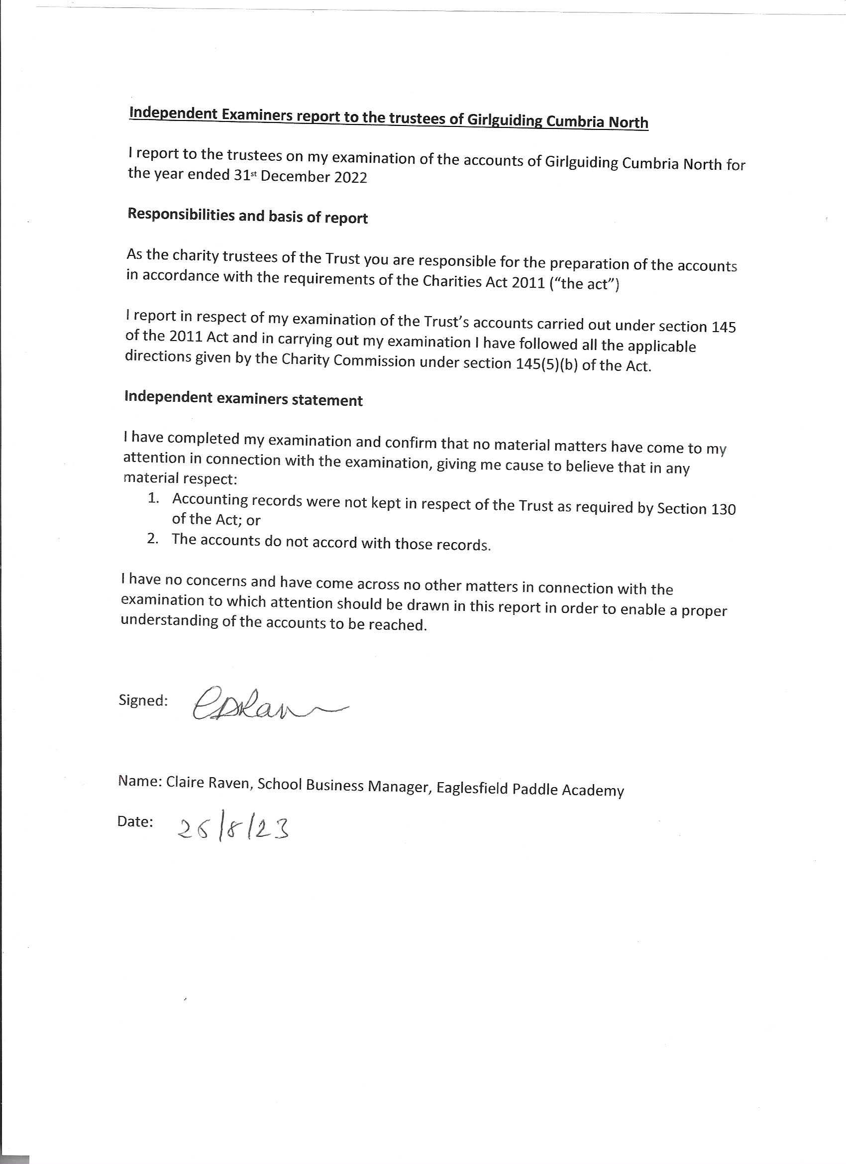

THE GUIDE ASSOCIATION – CUMBRIA NORTH COUNTY – REGISTERED CHARITY – 503517

INCOME AND EXPENDITURE ACCOUNT

FOR THE YEAR ENDED 31 DECEMBER 2022

|  |  |  |  |
| --- | --- | --- | --- |
| RECEIPTS | 2021 |  | 2022 |
|  |  |  |  |
| total grants and Donations  Transfer from Investment account | 0.00  - |  | 25,222.20  - |
| subscriptions from members | 3,214.00 |  | 3484.00 |
| interest received |  |  | 23.13 |
|  |  |  |  |
| legacies | - |  | - |
| camps/outings/events | - |  | 4480.00 |
| training | - |  | - |
| Merchandise | 502.60 |  | 216.20 |
| repayments of grants | -  264.12 |  | 210.00 |
| County Depot |  |  | 429.94 |
|  |  |  |  |
| TOTAL INCOME | 3,980.72 |  | 34065.47 |

|  |  |  |
| --- | --- | --- |
| PAYMENTS | 2021 | 2022 |
| Badges and Goods purchase for resale | 1,176.11 | 1564.38 |
| Training |  | 420.00 |
| Travel | - | 558.50 |
| Rent | - | 384.00 |
| Donations and grants to units | 420.00 | 11090.19 |
| Girlguiding Cumbria South | 8663.70 | 8232.00 |
|  |  | 396.00 |
| Subscriptions for County Personnel | 183.40 |  |
| Bank charges | 60.00 | 96.60 |
|  |  |  |
| County Materials | 1,868.97 | 5329.98 |
|  |  |  |
| camps/outings/event | 1,320.00 | 6112.09 |
| International |  | 440.00 |
| TOTAL EXPENDITURE | 21,739.98 | 34,623.74 |
|  |  |  |
| Surplus for year | (17,759.26) | (558.27) |

THE GUIDE ASSOCIATION – CUMBRIA NORTH COUNTY

REGISTERED CHARITY – 503517

STATEMENT OF ASSETS AND LIABILITIES AS AT 31 DECEMBER 2022

MONETARY ASSETS

|  |  |
| --- | --- |
| UNRESTRICTED | 2022 |
| Bank Current Account | 50,223.96 |
| Building Society | 80,000 |
| CAF Gold Account | 2278.58 |
| TOTAL MONETARY ASSETS | 132,502.54 |

OTHER ASSETS – ALL UNRESTRICTED

Held for use by the Charity

|  |  |
| --- | --- |
| Resuscitation models | Replacement value £520 |
| Display boards and pop up banners | Replacement value £710 |
| 4 X County Centenary banners | £1,000 |
| Camping Equipment | Replacement Value £9,500 |
| 2 x County Standards | Replacement Value £8,000 |
| Digital Projector | Replacement Value £1,000 |
| 8 x County Banners | Replacement Value £1,500 |
| 2 x Gazebos | Replacement Value £2,500 |

Approved by Trustees on and signed on their behalf.

Ann-Marie Steel

COUNTY COMMISSIONER

APPENDIX

Girlguiding Cumbria North Risk Register

It is appreciated by the Trustees that the Finances of the County need to be protected and preserved for the benefit of the current and future members of Girlguiding Cumbria North.

To this end the Trustees have considered and made policies regarding the finances of the County.

The rating is scored from 1 being very low risk to 5 being very high risk.

Risk Register

|  |  |  |
| --- | --- | --- |
| RISK | RATE | CONTROL |
| Cheque Signatories | 2 | Two signatories are required for all cheques, the signatories are any two of three named. |
| Authorisation of BACS payments | 2 | Dual authorisation is required for all on-line bank transactions, the authorisation is from any two of three named. |
| Delegation | 2 | The Finance Committee reports back to the County Executive and has limited authority to act without the consent of the County Executive. |
| Investments | 4 | The investments of the County have been spread between a Bank and a Building Society long term investment. The risk of an investment holder ceasing to trade is considered alongside the rate of interest available for larger deposits. The security of the investments is kept under constant review and authority has been given to the cheque signatories to move funds quickly if the Finance Committee of Trustees believe it to be necessary. |
| Equipment | 2 | The County do not own large amounts of equipment, the County does not hold insurance for insurable objects. The level of insurance cover has been carefully considered against the cost of insurance and the replacement value of some items. The insurance is reviewed annually and when new purchases are made. |