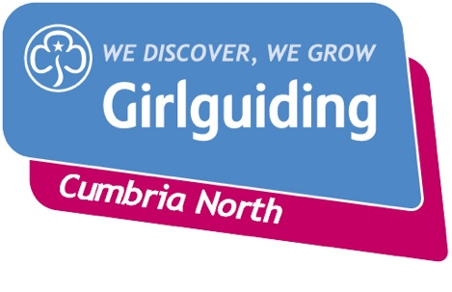
Cumbria North County Subscription Hardship grant

Name of Unit
Name of Leader
Contact telephone number and email address
Division
Date of application
Number of volunteers and girls on subscription invoice

To apply for assistance to help the unit pay subscription costs, please answer the following questions

- Have you contacted your parents to ask for financial contribution to subscription payments?

- Do you claim gift aid for your unit? If not, why not?

- Have you contacted your Division commissioner? If so, what help have you received?

- How much money are you applying for?

Please attach a copy your last accounts and latest bank statement.
Please send this form and required documents to.

Ann-Marie Steel, County Commissioner, countycommissionercumbrianorth@gmail.com
or post to; Abbeygate, Near Rogerscale, Cockermouth, Cumbria, CA130RE

